Technical and material

Specifications

Project: 21009_San Sousi Development
13.03.25

Content:
- Framework
- Damp proof and waterproofing
- Masonry
- Coatings
- Flooring
- Wall Tiling
- Sanitary, fixtures and fittings
- Suspended Ceilings -Plasterboard
- Aluminium works -Doors and Windows
- Mechanical
- Installation of electrical wiring
- Electrical
- Carpentry
- Lightings
- General features of the building
- General features of apartments

- Framework
Residential Block with reinforced concrete structure according to Eurocodes and Cyprus norms (anti-seismic design). Concrete will be C30/37-C50/47 and the high strength steel will be B500C.
The thermal insulation of the building will be classified as category A.

- Damp proof and waterproofing
Foundation:
- Polythene sheet between the soil and concrete foundation
- All the vertical surfaces that are in contact with the soil will receive two coats of two - component, flexible cementitious mortar MAPEI FUNDATION or equivalent (foundation, perimetrical wall, lift walls etc) according to manufacturer’s specifications.
- Dimple polyethylene membrane type FONDALINE 500gr/m2 or equivalent will be placed on all vertical surfaces that are in contact with the soil (foundation, perimetrical wall, lift walls etc).

Roof – communal areas:
- Two coats of cement Based insulation bitumen sheet 5m/m with stone on the surface of the concrete slab under the ceramics.
- Polymer - modified waterproofing membrane Extrabit P200 or equivalent according to manufacturer's specifications.
- Triangular sand - cement fillet will be constructed at the joint between parapet walls and concrete slab.

Roof - Roof Garden:
- Two coats of cement-based insulation or bitumen sheet 5m/m without stone on the surface of the concrete slab.
- Two coats of minimum thickness 2mm each of one component cementitious mortar SIKA MONOSEAL -101H or equivalent according to manufacturer’s specifications.

Covered verandas and non-accessible slabs:
Two coats of minimum thickness 2mm each of one component cementious mortar SIKA MONOSEAL -101H or bitumen sheet 5m/m based on manufacturer's specifications.

Showers:
- Two coats of total thickness 3mm of one component water-based elastomeric bitumen, waterproofing product UNOLASTIC or equivalent according to manufacturer’s specifications. The coats will be applied on floor and walls too.
- Reinforcement between the two coats with mesh RINFOTEX EXTRA or equivalent according to manufacturer’s specifications.
- Reinforcement mesh RINFOTEX PLUS or equivalent at the joint of floor with wall. Placement according to manufacturer’s specifications.

- Masonry

External Walls:
- The external walls will be constructed with 25cm and 30cm (based on the study) thermal hollow bricks (according to CYS19:1989) or equivalent, laid with cement paste.
- Plastic mesh will be placed at the joints of masonry with reinforced concrete members.
- Damp proof course will be placed at ground floor walls.

Internal Walls:
The internal walls will be constructed using a drywall system with metal stud framing. They will feature durable plasterboards on both sides, with rock wool insulation in between for enhanced acoustic and thermal performance. The finished surfaces will be plastered for a smooth and durable finish.
- Coatings

Internal:
- Masonry will receive three coats of sand/cement plastering.
- The ceilings will have a fair face finish and will receive two coats of spatula (levelling compound).
- The walls and ceilings will be painted with three coats of emulsion paint of the finest quality of which the colour will be chosen by the architect.

External:
- External walls will be insulated with 80mm of polystyrene according to the energy efficiency certificate.
- Exposed roof will be also insulated with 100 mm of polystyrene according to the energy efficiency certificate.

- Flooring
All the ceramic flooring / laminated parquet will be selected by the architect or by the purchaser at an early stage, so it does not affect the progress of the building.
Kitchen/Living/Dining Area/Bedrooms:
Ceramic tiles, laminate parquet with timber skirting will be placed, value of €30/m².
Verandas:
Ceramic tiles with matching skirting will be placed, value of €25/m².
Bathrooms:
Ceramic tiles will be placed, value of €25/m².
Bedrooms:
Ceramic tiles or laminate parquet with timber skirting will be placed, value of €25/m².

Roof Garden:
Ceramic tiles with matching skirting will be placed, value of €25/m².
Lobby/Elevator:
Marble or ceramic tiles of €50/m² chosen by the architect.

- Wall Tiling
All the ceramic for floor and wall tiling will be selected by the architect, or the purchaser at an early stage so it does not affect the progress of the building.
Bathrooms:
Ceramic tiles will be placed at a value of €25/m². The walls will be tiled up to the ceiling.

- Sanitary, fixtures and fittings
All sanitary fixtures and fittings will be selected by the architect or purchaser at an early stage, so it does not affect the progress of the building.
One – Bedroom Apartments:

Sanitary fixtures and fittings (Grohe or similar) of €1000 (including sinks, washbasins, mirrors, and accessories).
Two – Bedroom Apartments:

Sanitary fixtures and fittings (Grohe or similar) of €1700 (including sinks, washbasins, mirrors, and accessories).
Penthouse:

Sanitary fixtures and fittings (Grohe or similar) of €2200 (including sinks, washbasins, mirrors, and accessories).

- Suspended Ceilings -Plasterboard
There will be suspended ceilings out of plasterboard in all bathrooms and the living room, kitchen and dining area of the penthouse.

- Parking spaces & Storage areas
For every apartment, there is a covered parking space and one storage area. The parking space for apartment 103 is not covered but can be arranged upon request.

- Aluminium works -Doors and Windows
- All the exterior openings will have thermal break aluminium frames with Double Glazing.
- All balconies will have glass fencing as shown in the architectural plans.
- In case the purchasers require aluminium shutters, they will be charged as additional costs for the purchase and installation, at an early stage so it does not affect the progress of the building.
- Fly screens will also be charged as additional costs for the purchase and installation, at an early stage so it does not affect the progress of the building.

- Mechanical

Hot and Cold Water, Fire Protection
- On the ground floor of the building, there is a water feature.
- On the ground floor, there are shared faucets (with a lock) connected to the city's water supply network.
- A shared water meter is located on the ground floor.
- Additionally, on the ground floor of the building, there is a shared water storage tank from the city's network and a booster pump.
- The production of hot water at the WC sink on the ground floor is achieved through the installation of an instant water heater.
- Pipes (PE hoses) from the shared water meter run to all floors of the building for the irrigation of the flowerbeds.
- For all types of apartments, a thermosiphonic system for natural circulation will be installed to produce hot water for domestic use (solar panels, horizontal hot water cylinder, expansion vessels, etc.). A separate storage tank for domestic water will be installed, along with a pressurized system, return pump, piping, fittings, and hot and cold-water supply distributors with pipe-in-pipe type of piping for each apartment.
- The water meters for all apartments will be installed on the roof of the building (5th floor).
- In all kitchen sinks of all apartment types, there will be direct water supply from the city's network with the provision to install a water filter for potable water.
- In all WCs of all apartment types, a mixing valve will be installed for the Arabic shower.
- On all levels of the building, within the stairwell, there are single dry pipe fire hose reels (in accordance with the requirements of the Fire Department). Additionally, on the ground floor in an external area, there is also a double hose reel for the dry pipe fire system.
- The building will have a shared fire detection system for both common areas and apartments.

Air Conditioning and Ventilation
All necessary electrical and mechanical piping and wiring provisions for air-conditioning installations will be done in accordance with the electrical and mechanical drawings.
On the ground floor of the building, there is a ventilation unit for the WC area and provisions for the future installation of a wall-mounted split unit air conditioning system in the reception area.
One – Bedroom Apartments:

Provision for split-type air conditioning units: 1 wall-mounted unit with a wireless remote control for the bedroom and 1 ceiling-concealed (ducted) unit for the kitchen/dining room/living room with a wired control.
Two – Bedroom Apartments:

Provision for split-type air conditioning units: 2 wall-mounted units with wireless remote controls for the bedrooms and 1 ceiling-concealed (ducted) unit for the kitchen/dining room/living room with a wired control.
Additionally, there is a separate ventilation unit (activated by the light switch) for each apartment, for the sanitary areas that do not have windows.
Penthouse:

Provision for split-type air conditioning units: 5 ceiling-concealed (ducted) units for the bedrooms and the kitchen/dining room/living room, all with wired control panels.

Heating
One – Bedroom Apartments:

No heating. The purchaser has the choice to install underfloor heating with an additional cost for purchase and installation, at an early stage so it does not affect the progress of the building.
Electrical provision only for the future installation of a towel rail heating element in the sanitary area.
Two – Bedroom Apartments:
An integrated underfloor heating system (low profile type) is installed in all areas of the apartment, along with a central thermostat for the system.
The supply and installation of the external heating unit (heat pump) is not included.
Electrical provisions only for the future installation of towel rail heating elements in the sanitary areas.
Penthouse:
An integrated underfloor heating system (low profile type) is installed in all areas of the apartment, along with a central thermostat for the system. The supply and installation of the external heating unit (heat pump) is not included.
Electrical provisions only for the future installation of towel rail heating elements in the sanitary areas.

Sewage
The drainage piping network within the building floors consists of uPVC pipes, and within vertical ducts and at the highest point of the ground floor (surface-mounted), PP-3-LAYER soundproof pipes are used.

Plumbing installation:
- The plumbing installation to all sanitary units and the solar water heating panel will be of aluminium pipe of high pressure, according to international standards.
- It will include cold and hot water supply to the kitchen sink, bathtubs, shower mixers and washbasins. In addition, the plumbing installation includes cold water supply for washing machine and dishwasher wherever indicated on the mechanical drawings.
- Each apartment will be provided with electric boiler and storage (volume 150/160litres), one solar heating panel of 2.42m² (2-bed apt) / 1.5m² (1-bed apt) and water storage tank of 1000lt according to the mechanical.
- Pressure water systems for all flats.

Energy Efficiency:
- The whole building is designed in accordance with the European Engineering Regulation and the building is categorized as energy class A.
- Installation of photovoltaic panels for each flat. Additionally, the production of some panels will compensate for the cost of electricity of common expenses.

Elevator
Luxurious and latest technology Electric elevator from KONE, according to EU standards, for 8 people/630kg without a mechanical room, speed v=1m/s, 6 stops.

- Electrical
- All apartments and common areas will be executed according to the 17th Edition of the electrical installations.
- The electrical installation will be in accordance with the relevant plans and the current EAC regulations. All electrical conduits will be cast within slabs, floors, and walls.
- In case the purchaser chooses to install light fittings other than the ones predefined by the vendor, they will be charged with the cost of the purchase and installation of those fittings.
- Full electrical installation switch and sockets will be LEGRAND or equivalent in white colour.
- In the parking area on the ground floor, provisions will be made for an electric car charger for each parking space.
- At the vehicle entrances in the parking area, provisions will be made for the installation of electrically operated gates.
- In the bedrooms of the apartments, provisions will be made for electric blinds.
- On the terraces of the apartments, there will be waterproof power outlets.

Home Intercom
The building will have an external video intercom system with access control. Inside each apartment, there will be an internal video intercom device. Additionally, the back entrance will also be controlled by an access control device.

Television System
The building will have a shared television antenna and TV points in the living room and bedrooms of each apartment.

Telephone & Network System
The building will have a shared fiber optic network and network points (cat6) in the living room and bedrooms of each apartment.
Each owner will be able to sign a contract for a landline phone or internet service with any provider they choose.

Camera/Security System
The building will have shared security cameras in the parking area and at the entrance of the building.

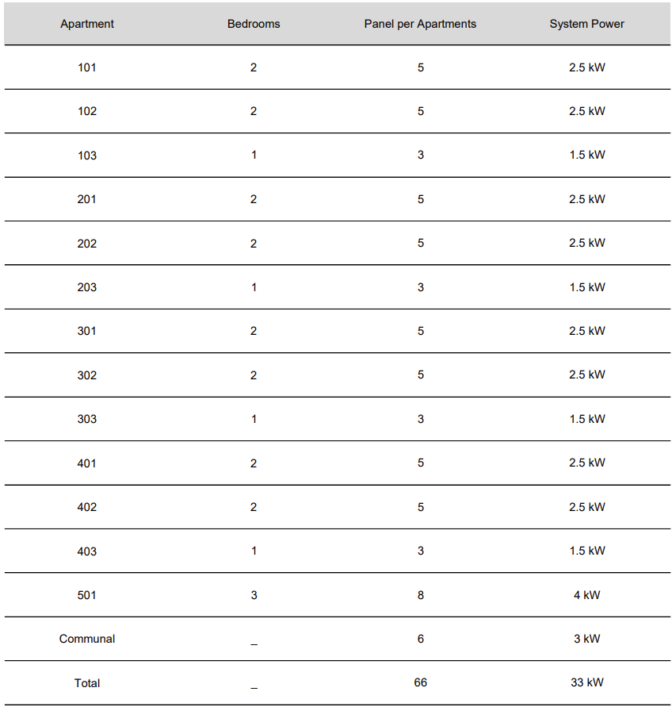
Photovoltaic System
The building will have the possibility for all apartments to install photovoltaic (PV) systems, as shown below.
- Carpentry
Kitchen:
- Kitchen will be laminate melamine – €250/l.m. in colour chosen by the architect or the purchaser at an early stage so it does not affect the progress of the building.
- Kitchen worktop and backsplash will be of granite or porcelain at €150/l.m. in colour chosen by the architect or the purchaser at an early stage so it does not affect the progress of the building.
- All kitchen mechanisms will be soft close.
- Kitchen sink will be of a stainless-steel single bowl.

Wardrobes:
All wardrobes will be laminated – €180/l.m. with dimensions according to the architectural drawings, in colour chosen by the architect or the purchaser at an early stage so it does not affect the progress of the building.
Wardrobe handles will be chosen by the purchaser from a predefined selection of the vendor.

Internal doors:
- All the internal doors of the apartments (€400 each) will be imported prefabricated doors with solid wood frame, in colour chosen by the architect or the purchaser at an early stage so it does not affect the progress of the building.
- Internal apartment handles will be chosen by the architect or the purchaser at an early stage, so it does not affect the progress of the building.
- Main entrance door of the apartments (€700 each) and communal stairwell doors will be of laminated wood with solid wood frame and a handle, all in a colour chosen by the architect.
- Main apartment door and communal stairwell doors will be fireproof according to the EU regulations.

Other Woodworks:
Bathroom cabinet – €180 m²
Bathroom cabinet Bench tops – €150 m

Handles
- One – Bedroom Apartments:

Doors, wardrobes - €200
- Two – Bedroom Apartments:
Doors, wardrobes - €250
- Penthouse:
Doors, wardrobes - €300

Mailboxes:
Based on the architectural drawings.

- Lightings

Communal areas:
Installation of the lighting in all communal areas according to the architectural drawings.

Verandas:
Installation of the lighting in all verandas according to the architectural drawings.
Flats:
Installation of a hidden linear lighting fixture in all bathrooms.

- General features of the building
- Provision for electric charging station for every parking position.
- Installation of door phone system at the entrance of the block.
- Electric parking gates
- Security cameras in parking ground floor
- Installation of automatic watering for the garden

- General features of apartments
Apartments:
- Door Phone System
- Telephone Outlet
- USB socket - optional
- Provision for smoke detectors.
- Provision for Internet and wi-fi access points
- Electric doorbell
- Each flat will be provided with solar panels.

Bedrooms:
- Provision for AC
- Electrical sockets

Kitchens:
- Provision for kitchen hood extractor
- Provision for electric oven
- Provision for washing machine.
- Provision for dishwasher
- Provision for fridge
- Electrical sockets

Verandas:
- Electrical sockets
- Water supply

Special Provisions
- The main entrance of the building will communicate by intercom camera with each apartment.
- The main door will open with a card or a code.
- Steel rails will be placed on the staircase of the building.

Notes:
19% VAT is not included in the mentioned prices above.

